EXXON VALDEZ OIL SPILL
Name:
Institutional Affiliation:
Instructor:

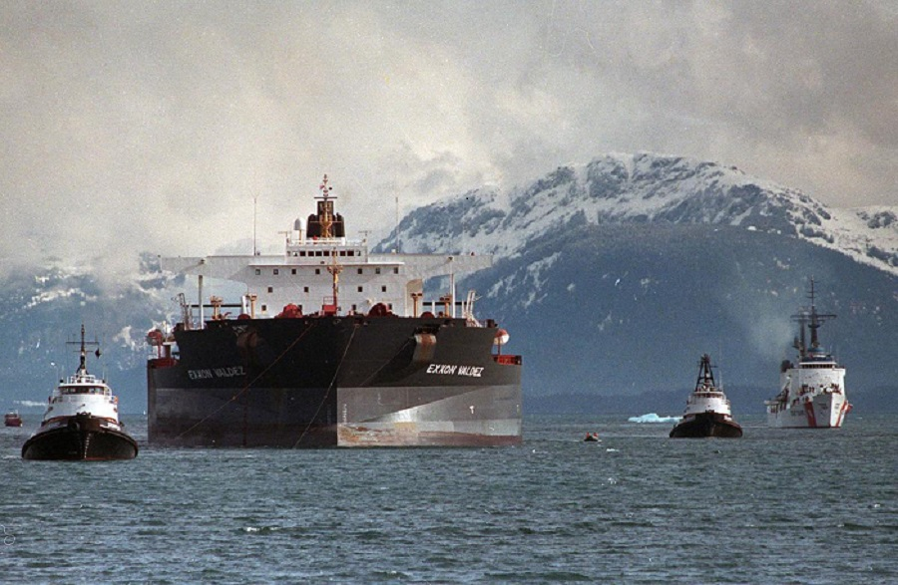

Exxon Valdez Oil Spill on Prince William Sound
In March 24th, 1989 the Exxon Valdez tanker ran aground by hitting reef in Prince William Sound (Prince William Sound is an inlet in the Alaskan Gulf in the United states) and spewed an estimated eleven million gallon of oil causing America’s second most catastrophic man made environmental disaster ever known till today. Efforts to contain and manage the oil spill were delayed and thus caused dispersal of the oil across the sound. Twenty-nine years later the effects of the catastrophe are still seen (Taylor, 2014).
The Exxon Valdez was an oil tanker owned by the Exxon shipping company. The ship was bound for long beach California. However, the ship struck Prince William sound’s Bligh reef at approximately 0004 hrs. The tanker Is noted to have spilled approximately 10.8 million US gallons of crude oil over the ocean floor from that point and in the next few following days. As is noted the crude oil was spread across the Sound for miles by strong winds and storms which caused the massive oil spill to practically flood over the inlet. The effect of the spill was disastrous and hence it has been labeled as one of the most catastrophic environmental man-made disasters to date (Taylor, 2014).
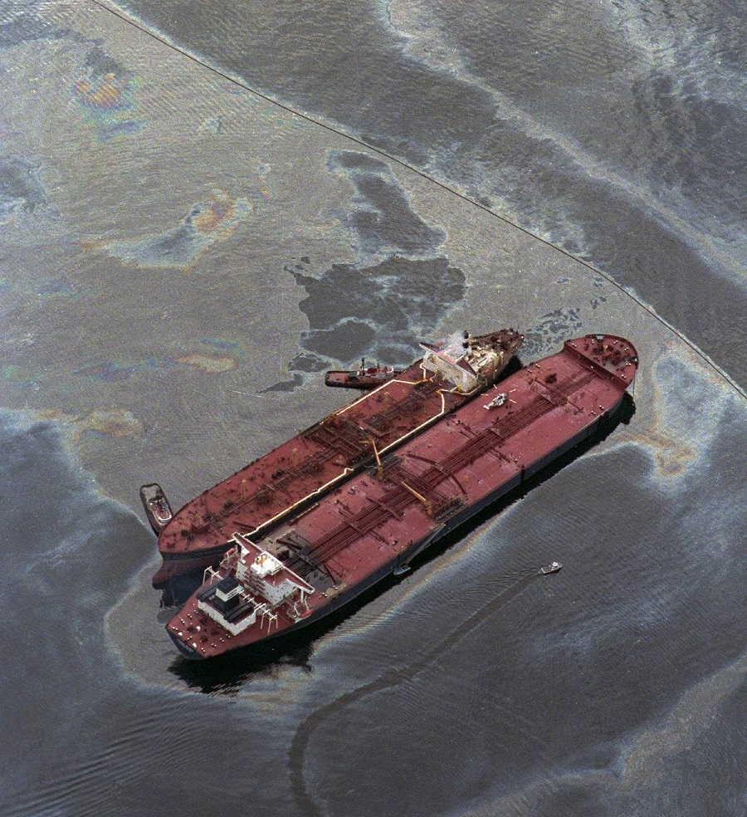
The effect to Prince William Sound was enormous. It is estimated that about one thousand miles of coastline were fouled due to the slow response which caused storms to blow the crude oil along the coastline and ocean floor for miles. Even more devastating was the death of hundreds of thousands of animals which were killed due to the massive oil spill that occurred in the area. In breaking this into detail the oil spill caused the death of approximately two thousand sea otters, three hundred and two harbor seals and an estimated two hundred and fifty thousand sea birds which died in the days following the spill (LATSON, 2015).
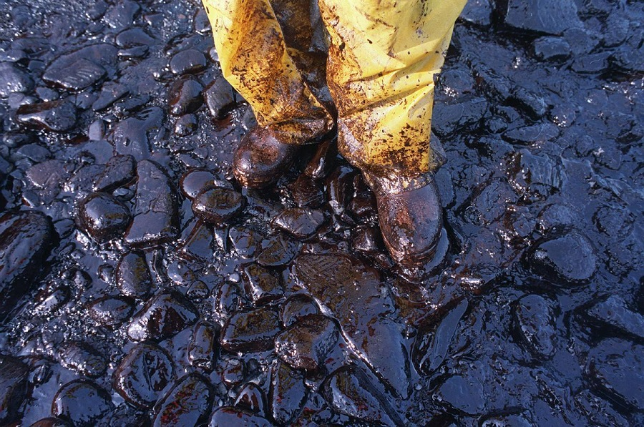
Research conducted by Charles H. Peterson, who is situated at the University of California, his colleagues shows that till to date a significant amount of north slope, or crude oil, is still persistent. The research states the long-term effects of the oil spill could be more devastating than anyone could imagine. According to their research significant quantities of oil have been trapped under intertidal sentiments. These quantities of oil have been in sequestered conditions of weathering while also undergoing inhibited exposure to light and bacteria. This makes the oil quantities more toxic to marine life. Marine animals like salmon increased their mortality rate after the oil spill while larger mammals suffered as well due to their prey being oil contaminated (Shin, 2017).
The Exxon Valdez captain was charged on a misdemeanor charge where he was fined fifty thousand dollars and one thousand hours of community service for his role in the oil spill. He was however acquitted of being under influence of alcohol while manning the helm which could have landed him more serious punishments. The Exxon corporation assigned about two billion dollars for the clean up mission of the inlet, but they were also found incompetent by the National Transport and Safety board for overworking their crew (Shin, 2017).
The US coast guard was also found at fault for what was considered an inadequate system of traffic regulation. The captain, Joseph J. Hazelwood though acquitted, had his employment contract with Exxon terminated due to the rising claims and evidence that suggested he was drunk at the time of the incident. The Exxon Valdez was repaired and resumed work but was banned from entering the Prince William Sound ever again through a clause in law that made it so.
Till to date there is a lot of information that states that the oil spill effects are still there. A scientist told Time in 2009 that even though the oil may not leak out in noticeable quantities it is still there. Random tests along the shoreline have revealed that there are an estimated twenty thousand gallons of oil remaining. This shows that the clean-up wasn’t a one-time event, but it was supposed to be a long-ended process that was supposed to leave the shoreline free from the effects of the oil spill. On the oil spill’s twenty fifth anniversary it was discovered that about thirteen of the thirty-two affected wildlife populations had fully recovered (Graham & Graham, 2003).
The lessons learnt from the gulf spill taught Americans on how to better respond to oil spills for one. However, on a more larger scale the oil spill legal ramifications brought more accountability to Oil corporations and thus made the oil business safer since now oil corporations are scrutinized more and they have more accountability on the same (LATSON, 2015). The response of animal rescue centers as at 1989 was also tested and tried and this led to an increase in funding for the same. This was due to the heavy animal losses experienced at the time of the oil spill. All in all, a CNN researcher, Marybeth Holeman notes in an opinion piece that we will never be able to reduce the risk of oil spills to zero no matter how safe we make oil drilling, tankers and pipelines.
References
Graham, S., & Graham, S. (2003). Environmental Effects of Exxon Valdez Spill Still Being Felt. Scientific American. Retrieved 25 March 2018, from https://www.scientificamerican.com/article/environmental-effects-of/
LATSON, J. (2015). America’s Second-Worst Oil Spill Is Still Scarring the Shores of Alaska. Time. Retrieved 25 March 2018, from http://time.com/3748246/exxon-valdez-history/
Shin, A. (2017). The Exxon Valdez oil spill. Washington Post. Retrieved 25 March 2018, from https://www.washingtonpost.com/lifestyle/magazine/the-exxon-valdez-oil-spill/2017/03/14/d131b630-f876-11e6-9845-576c69081518_story.html?utm_term=.7d6721b5eadb
Taylor, A. (2014). The Exxon Valdez Oil Spill: 25 Years Ago Today. The Atlantic. Retrieved 25 March 2018, from https://www.theatlantic.com/photo/2014/03/the-exxon-valdez-oil-spill-25-years-ago-today/100703/

AP Photo/Al Grillo
AP Photo
AP Photo/John Gaps III

